SET 14
Aim
To visualize and analyze survey response data using a stacked bar chart, radar chart, table, and a Tableau dashboard.
Data: SURVEY RESULTS
Respondent | Question 1 | Question 2
1 | A | B
2 | B | A
3 | C | A

PROGRAM 1: Stacked Bar Chart of Question 1 Responses
Create a stacked bar chart to display the distribution of answers for Question 1. Label the chart elements.
# Create survey data
respondent <- c(1, 2, 3)

question1 <- c("A", "B", "C")
question2 <- c("B", "A", "A")
question3 <- c("C", "D", "B")

data <- data.frame(respondent, question1, question2, question3)

# Count Question 1 responses
q1_count <- table(data$question1)

# Create stacked bar chart
barplot(q1_count,
main = "Distribution of Question 1 Answers",
xlab = "Answer",
ylab = "Number of Responses",
col = c("skyblue", "orange", "lightgreen"),
border = "black")

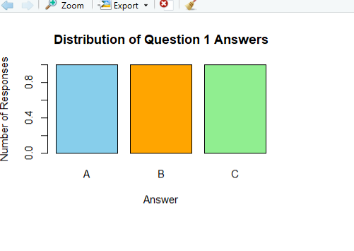
Output 1: Question 1 Stacked Bar Chart
Observation
The stacked bar chart displays the distribution of answers for Question 1. Answer A, B, and C each have one response.

PROGRAM 2: Radar Chart of Overall Survey Responses
Generate a radar chart to visualize the overall pattern of responses across all three questions.
# Count answers across all questions
answers <- c(data$question1,
data$question2,
data$question3)

answer_count <- table(factor(answers,
levels = c("A", "B", "C", "D")))

# Radar chart
values <- as.numeric(answer_count)

angles <- seq(0, 2*pi, length.out = 5)

values <- c(values, values[1])

plot(angles, values,
type = "o",
pch = 19,
lwd = 2,
xaxt = "n",
main = "Overall Pattern of Survey Responses",
xlab = "",
ylab = "Number of Responses")

axis(1,
at = angles[1:4],
labels = c("A", "B", "C", "D"))

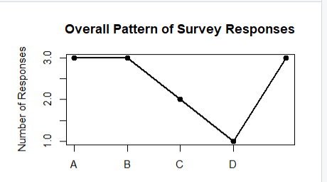
Output 2: Radar Chart of Survey Responses
Observation
The radar chart shows the overall pattern of responses across the three questions. It helps compare the frequency of answers A, B, C, and D.

PROGRAM 3: Table of Survey Response Data
Build a table to show the survey response data for each respondent. Label the table elements.
# Create survey response table

survey_table <- data.frame(
Respondent = c(1, 2, 3),
Question_1 = c("A", "B", "C"),
Question_2 = c("B", "A", "A"),
Question_3 = c("C", "D", "B")
)

# Display table
print(survey_table)

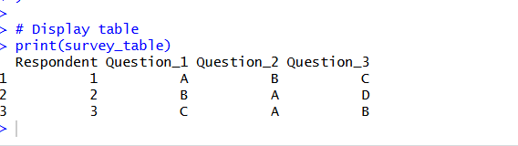
Output 3: Survey Response Table
Observation
The table displays the responses given by each respondent for all three questions. It provides a clear view of the complete survey data.

PROGRAM 4: Tableau Dashboard for Survey Results
Develop a Tableau dashboard combining the stacked bar chart, radar chart, and table for interactive exploration of survey responses.
Procedure
- Open Tableau and connect the Survey Results dataset.
- Create a Stacked Bar Chart using Question 1 responses.
- Create a Radar Chart to display the overall response pattern across Question 1, Question 2, and Question 3.
- Create a Table containing Respondent, Question 1, Question 2, and Question 3.
- Create a new Dashboard in Tableau.
- Add the Stacked Bar Chart, Radar Chart, and Table to the dashboard.
- Arrange the charts and table properly for clear visualization.
- Add filters or interactive options to allow users to explore the survey responses.
- Give the dashboard a suitable title such as “Survey Results Dashboard”.
- Save the Tableau dashboard.
Output:
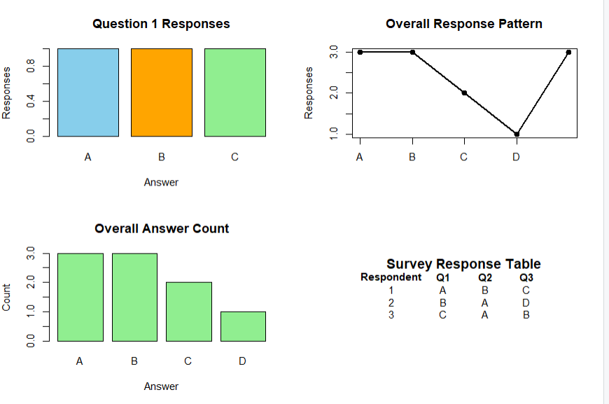
Observation
The dashboard combines charts and the survey table in one view. It allows the user to easily compare the distribution and overall pattern of survey responses.

Set 14 Procedure
- Create a survey response dataset containing respondent number and responses to three questions.
- Use R to create a stacked bar chart showing the distribution of Question 1 answers.
- Create a radar chart to visualize the overall pattern of responses.
- Create a table to display the survey responses for each respondent.
- Import the survey dataset into Tableau.
- Create the stacked bar chart, radar chart, and table in Tableau.
- Combine the visualizations into a dashboard for interactive exploration.
Set 14 Result
Survey response data was successfully visualized using a stacked bar chart, radar chart, and table. A dashboard was also designed to combine the visualizations and provide a clear view of the overall survey response patterns.

